Kalibrieranleitung Digi-Waage DS 781 - 782
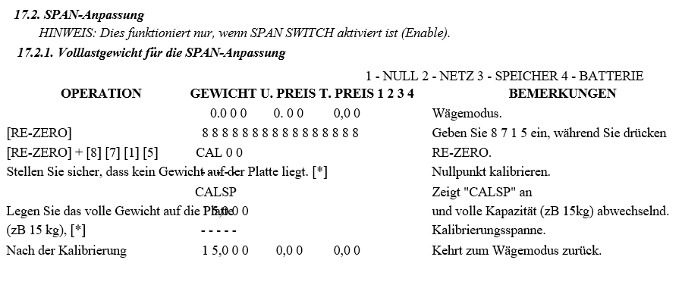-------------------------------------------------------------------------------------------------------------------------------------------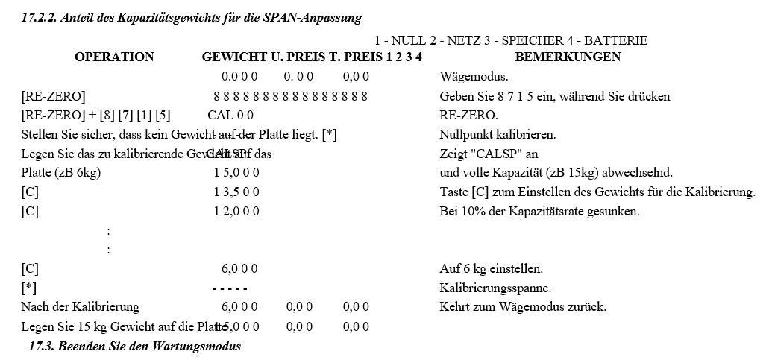--------------------------------------------------------------------------------------------------------------------------------------------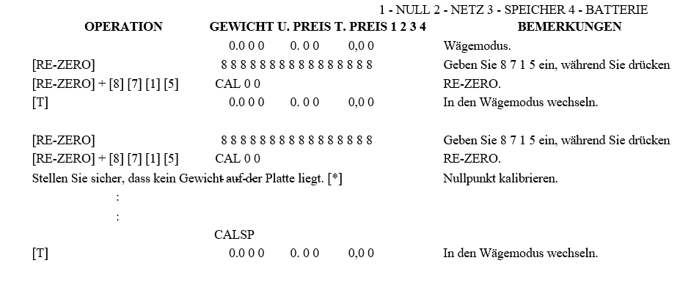

Kalibrieranleitung Digi-Waage DS 685

